BEAUFORT
LAKE GOLDSMITH
SNAKE VALLEY
STONELEIGH LANDCARE NEWS
Part of the UMEC Landcare Network
(2017-03)
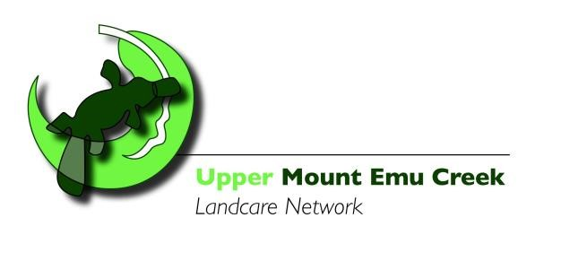
ABN 82 141 562 499
Correspondence to: PO Box 21,
LEXTON VIC 3352

NETWORK FACILITATOR
Joel Owins Tel: 0457 008 895 owins22@hotmail.com

NETWORK COORDINATOR
David Clark Tel: 0417 374 704 garvagh@bigpond.com

Forthcoming Events
Q Fever Clinic
Tuesday October 17th & 24th
Skipton Medical Centre

Mullawallah Wetlands Tour
Monday November 27th
Time and Venue TBC

Mullawallah Wetlands Tour
At the next Landcare Network meeting, we are holding a walk and talk session at Mullawallah wetlands. The walk will be an informative session about the wetland and its unique flora and fauna.

A BBQ will be held after we have finished the walk and then we will commence the official network meeting. We encourage all members to come along and join in the night.
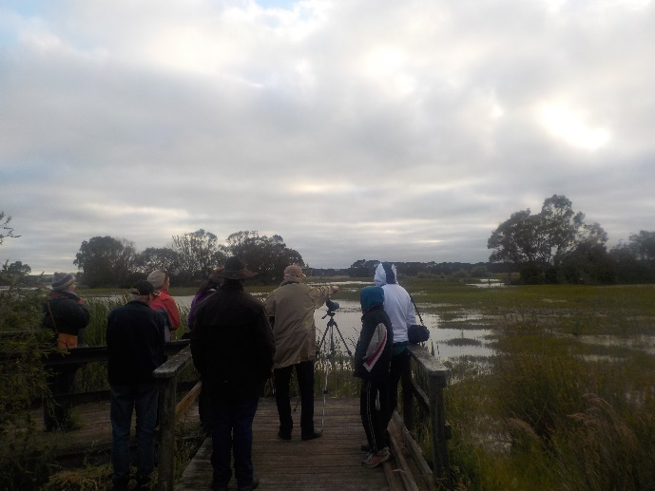

Photo: A previous event held by Cardigan Windermere Landcare group at Mullawallah Wetlands.

GHCMA Mt Emu Creek Waterway Action Plan

The Mt Emu Creek Waterway Action Plan (WAP) project is now entering the second and final year of project funding. The current target area (2017-18) is Mt Emu Creek from Skipton to Darlington. Projects are able to be developed from both of these areas for on-ground works in 2018 and submitted for project funding at the CMA.
The Expression of Interest timeframe closes on 29 September 2017. Anyone with land adjacent to Mt Emu Creek in either of these target areas and is interested in undertaking waterway protection works including stock exclusion fencing, revegetation or protection of remnant vegetation can contact Tania Parker at Glenelg Hopkins CMA on 5571 2526 for more information or to register your interest.

Kangaroo – Control
Kangaroos are one of our most iconic and well known species in our region, they play a highly important role in how our natural ecosystem functions. Since European settlement we have changed the lay of the land, which has caused in many cases over population. Land use has enabled Kangaroos to survive through the toughest droughts, with an abundance of artificial water sources scattered throughout their range.

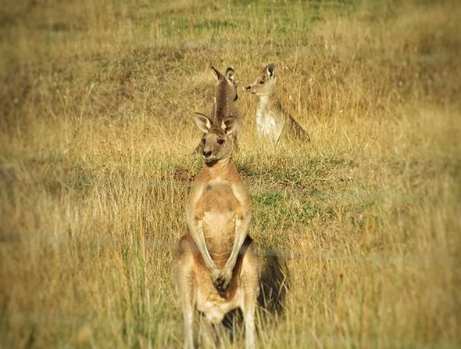
Kangaroos being a native species of Australia means they are protected under the Wildlife Act, it is illegal to cull them regardless of what damage or numbers they may be in without approval.
DELWP can issue Authorities to Control Wildlife (ATCWs), where it is demonstrated that they are causing considerable damage and loss to agriculture and/or other ecological values. Applications forms are available through the DELWP website or nearest DELWP office.

1080 Use (Fox Baiting)
1080 is a very effective poison to reduce fox numbers in an area. When used with care it can be safe for humans, non-target animals and the environment. It is a Schedule 7 poison which means it can only be purchased and used by ‘authorised persons’, to become an authorised person you must undertake specific training in the use of the product.

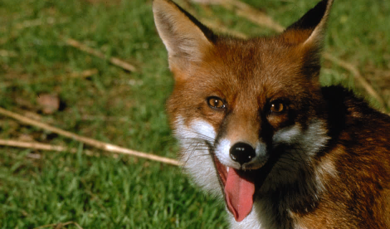
Source: Agriculture WA

The most effective poisoning periods are achieved from late winter to the end of spring. During this time of year food demands are high with the rearing of fox young. Ideally, a district wide approach is needed to significantly reduce numbers and increase the time it takes for reinfestation of the pest.

For further information visit about required permits: www.agriculture.vic.gov.au

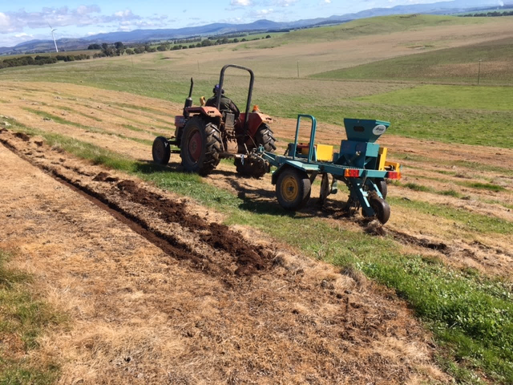
TREE POTS
If you have any tree pots from this or last year’s free trees program we would love to collect them. These pots are reused for future free tree programs. Contact Joel to organise pick up or simply bring them to the next meeting.

PROJECT UPDATES
We have had a great run of weather lately, this has made ideal conditions for planting native trees and direct seeding works across the region.

Last year’s projects that were direct seeded now have well established immature trees and shrubs growing. Due to the lengthy wet period we had last spring, the germination rate is high; producing a diverse mix of trees, shrubs and excellent growth rates.

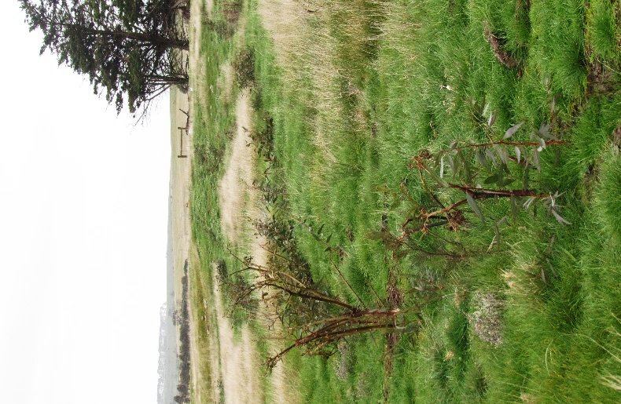

Picture: Successful germination of direct seeding, a great mix of all different natives. Chepstowe, along Ballie Creek (2017).

Picture: David Clark direct seeding on steep terrain, on the hills of Waubra (2017).



